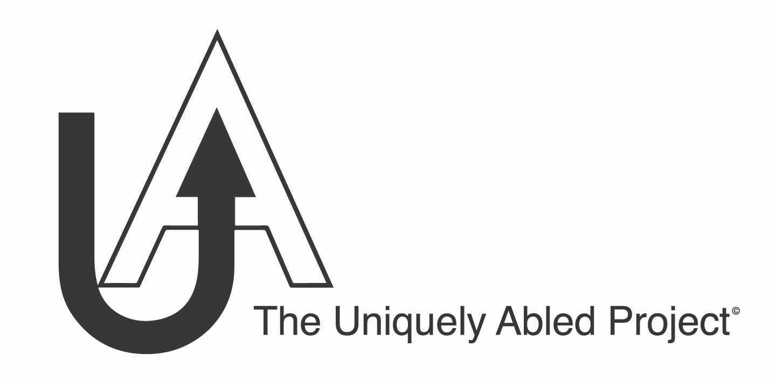

**STUDENT MEDIA RELEASE FORM**

PLEASE READ CAREFULLY BEFORE SIGNING.

Name of Host School: ____________________

I hereby grant **The Uniquely Abled Project** and the **Host School** permission to reproduce my name, likeness, identity, voice, photographic image, videographic image, and oral or recorded statements/testimonies in any publication, including those intended for research, educational, promotional, fund-raising, or other related uses, including webpages and social media platforms.

I acknowledge that **The Uniquely Abled Project** will rely on this waiver and release inproducing, broadcasting, and distributing materials (collectively “**Recordings**”) containing my name, likeness, identity, voice, photographic image, videographic image **or** oral or recorded statements, and that I will receive no money or remuneration of any kind from **The Uniquely Abled Project** related to this waiver and release or the materials covered by this waiver and release.

By signing this form, I waive and release **The Uniquely Abled Project** and the **Host School**,and their officers, agents, and employees**,** fromany claim or liability relating to the Recordings. I hereby waive any right that I may have to inspect or approve the finished Recordings. I understand that the Recordings and copyright thereof will be the sole property of**The Uniquely Abled Project**.

I acknowledge and represent that I am over the age of 18, have read this entire document, that I understand the contents**,** meaning, and impact ofthis waiver and release, and that I have signed it knowingly and voluntarily on behalf of myself.

Executed this __________ day of _________________ 20__

Signature: _______________________________________________

Print Name: ______________________________________________